

BOUDHA BAHANUPATI PROJECT Kalyan Yojana-PARIWAR

(BBP PARIWAR)

EST Date: 2051B.S (1994A.D)

Address: Banepa-6, Budol, Kavreplanchok

Ph no: 9841263404

Email:bbppariwar2051@gmail.com

About us: BBP PARIWAR is a non-profit voluntary organization registered with District Administration Office and affiliated with Social Welfare Council since 1994 AD (2051 BS)and is continuously operating different types of social development programs at three districts, Sindhupalchok, Ramechhap and Kavreplanchok. With a belief that only integrated development of the society can be sustainable development, this organization mobilizes local resources with the participation of backwarded, marginalized and communities at risk in the society by mobilizing local resources for health, education, agriculture, animal husbandry, herbs, forest conservation, drinking water and development of local infrastructure. The family is also working as a roof organization to increase the capacity of the other three organizations to give and get the maximum productivity. Samaj Sewa Samuha, Kavre, Nauling Swastha Sewa Kendra, Sindhupalchok and Bajra Samaj Nepal, Ramechhap are working as member organization of BBP Pariwar. Therefore this organization has been carrying out social service activities independently as well as an organizational network. Since 1994 conducting various programs and activities for the upliftment of the poor and marginalized women and men by empowering them with different capacity building activities in order to help them become self-reliant. BBP Pariwar’s focus is on reproductive health, women’s issues, saving and credit group program, non formal education, community based natural resources management, community development activities like drinking water, micro-irrigation etc.

Our Approach: BBP Pariwar strengthens the capacity of the people of backwarded and marginalized communities and the farmers to create a convenient working environment and to empower them with different capacity building trainings and activities for the upliftment of their economic as well as intellectual status to help them become self-reliant and also focuses on the reproductive health, women’s issues, education, community based natural resources management, sustainable community development activities etc.

. We work with small holder farmers Janajati, Tribal communities and the socially excluded (Dalit’s) prioritizing marginalized women to address the main cause of social and economic vulnerability, food insecurity, health and environmental issues. Our approach positively improves the community participation in existing economic, social, educational, health and environmental issues.

* BBP Pariwar supports farmers and marginalized communities especially women through formation of groups with a motive that, `` groups are the entry point for any development activities’’ to improve the livelihoods of marginalized communities.
* Then various development activities like irrigation system, drinking water, non formal education, agro foresty, environmental programs, trainings, health camps etc. are conducted in order to improve the economic, social, and intellectual and health status of the participants in order to spread these approaches through participants to other peoples.
* BBP Pariwar introduce the means of the agro ecological farming system, livestock husbandry(goats and buffalo), for the small holder farmers and facilitate and provides necessary support for them while they start the ecological farming principles on their farm
* BBP Pariwar, works as a roof organization for the local NGO’S facilitating them and developing their capacity to improve and expand activities in sustainable manner providing the sustainable preventive and curative health services, educational sector, community development as well as advocates for the improved facilities.

|  |
| --- |
| Samaj Sewa Samuha:  A local NGO founded in 1991 AD (2048 BS) located at Mandandeupur Municipality ward no 7 Kuntabesi to improve the wellbeing of the marginalized populations especially women’s form the Janajati, Tribal communities and the socially excluded (Dalit’s) living in the remote areas facilitating in different sectors like education (scholarship program), drinking water, promotes the ecological agriculture, strengthens community groups/organizations and improves community access to general and reproductive health services. |

Our partners:

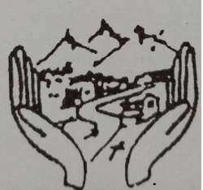

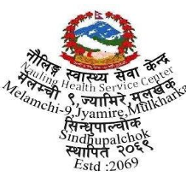

|  |
| --- |
| Bajra Samaj Nepal:  Bajra Samaj Nepal (BSN) is a non-profit organization located at Ramechhap Municipality, Ward no-6, Ramechhap Nepal formed by local young people, teachers women, farmers and ordinary community people for carrying out sustainable development activities in Ramechhap district in 2012 AD (2068 BS). Bajra Samaj Nepal empowers deprived community of Ramechhap to enhance their knowledge in health & sanitation, livelihood and education. |



|  |
| --- |
| Nauling Health Service Centre:  Nauling Health Service Centre founded in 2012 AD (2069 BS) located at Melamchi Municipality Ward no-9 to facilitate the local peoples of the remote areas mainly in the sector of health and also is facilitating the economically backwarded students by providing scholarship programs and is continuously and effectively conducting the medical camps and also is promoting the agro ecological means of farming systems and conducting various sustainable community development through the formation of women saving and credit groups for the social, economical and intellectual growth of the farmers and women living in the community. |

Supporting organizations:

|  |
| --- |
| Groundswell international is a partnership of local organizations and their network of grassroots community groups and is working in West Africa, America, and South Asia. Groundswell’s programs catalyze the transition from unsustainable agriculture and extractive economies to regenerative, just farming and local food systems. Communities and family farmers improve their wellbeing, produce more abundant and nourishing food in ecologically sustainable ways, increase their incomes, build resilience to climate change, and strengthen local economies and cultures. |



|  |
| --- |
| Friends of Nepal Pariwar Foundation is a non-profit organization supporting the health services for women through the help of registered non-profit community organizations in Nepal to improve the health and well being of women and their families in rural Nepal and strengthening their capacity to sustain and expand health services and support development, particularly improved drinking water and educational opportunities, in remote and socially excluded and tribal communities. |

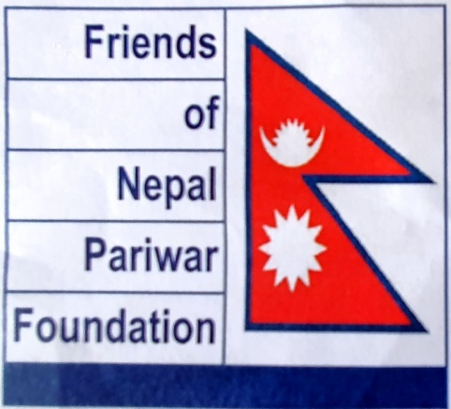

|  |
| --- |
| World Neighbors is an international development organization that works to alleviate hunger, poverty, and disease in the most isolated rural villages in Asia, Africa and Latin America. World Neighbors does not give away food or material aid, but provides a big-picture, holistic approach focusing on the entire community rather than on one issue. With a conclusion that problems and issues within a community are all interrelated and cannot be solved in isolation World Neighbors invests in people and their communities by training and inspiring them to create their own life changing solutions through programs in agriculture, literacy, water, health, leadership, financial management and environmental protection. |



|  |
| --- |
| American Jewish World Service supports more than 500 social justice organizations in 18 countries in Africa, Asia, Latin America and the Caribbean. American Jewish World Service focus is on civil and political rights, sexual health and rights, ending child marriage, humanitarian and disaster response, achieving gender equality, land, water, and climate justice etc. American Jewish World Service is leading campaigns for human rights and other supporter of human rights to promote the justice and equality in developing countries. |



Our Impact:

Since our foundation in 1994, until now BBP Pariwar has been conducting participatory sustainable community development programs, health services and camps, in three different districts of central Nepal Sindhupalchok, Ramechhap and Kavreplanchok in collaboration with our partner organizations.

* Works with the partner organizations to provide health services for around 20000-24000 peoples in a year especially for women of rural area and is organizing the medical camps for women health issues and also is providing scholarship for the formal agriculture, animal health, ANM (Auxiliary nurse midwife) education with an objective of providing service to the community and to uplift their economic status.
* By conducting the health camps for women diseases (like cervix cancer, eyes, teeth, throat, family planning, reproductive health) every year BBP Pariwar is providing the special health service for around 1100 women’s in a year.
* With the help of BBP Pariwar, farmers are able to produce and use liquid manure, organic pesticides, organic manure, compost manure, vermicompost etc in their field to maximize the production and to avoid the consequences from the use of the chemical fertilizers in the soil and human beings.
* Every year farmers are doing home nursery of different types of fodder grasses around 53000 and are cultivating them in their fields to provide the nutritious grass for their livestock without affecting the crops.
* Women members of the groups are able to establish mutual proximity in the community and food security through the cultivation of various value added fruits and vegetables, herbs and are generating income through the help of the livestock husbandry like goat, swine, cow and buffalo, stall improvement program with the financial, technical and educational support and guidance of BBP Pariwar and also are participating in the various educational tour in order to be capable of managing them in well manner.
* Saving and credit program is being conducted in the community especially with women’s participation in order to fulfill the needs like enrollment of the children’s in the school, health treatment, economic growth etc. Due to which women’s are getting priority on home and community as well as are able to increase the self confidence also.
* With the successful community participation construction of the drinking water and its maintenance has been done as a result women are able to save time to bring water and spend that time on productive work.

|  |  |
| --- | --- |
| S.N | Name |
| 1 | Mr. Thomas L. Arens |
| 2 | Mr. John Carr |
| 3 | Mr. Gopal Kumar Nakarmi |
| 4 | Mr. Bhagat Bahadur Bista |
| 5 | Mrs. Saraswoti Gautam Bista |

Our Board: Our Advisors:

|  |  |  |
| --- | --- | --- |
| S.N | Name | Position |
| 1 | Mr. Bharat Bista | President |
| 2 | Mrs. Shanti Basnet | Vice-president |
| 3 | Mr Chudamani Nepal | Secretary |
| 4 | Mr. Bishnu Pratap Khadka | Treasurer |
| 5 | Mr RamKrishna Chapagain | Member |
| 6 | Mrs.Devi Gurung | Member |
| 7 | Mr. Ramji Dhakal | Member |

Our Staff’s:

|  |  |  |  |  |  |
| --- | --- | --- | --- | --- | --- |
| S.N | Name | Position | S.N | Name | Position |
| 1 | Kalpana Bista | Program coordinator | 10 | Til Kumari Thapa Magar | Social Mobilizer |
| 2 | Anju Gautam | Program coordinator | 11 | Gita Basnet | ANM |
| 3 | Sharmila Ghorasaine | Accountant | 12 | Asmita Shrestha | Staff Nurse |
| 4 | Binita Sapkota | Social Mobilizer | 13 | RamMaya Tamang | ANM |
| 5 | Srijana Chaprakar | Social Mobilizer | 14 | Binda Aryal | Clinic In charge |
| 6 | Mangali Tamang | Social Mobilizer | 15 | Sita Maya Tamang | Group Facilitator |
| 7 | Sumitra Khatri | Social Mobilizer | 16 | Ramkrishna Karanjit (Parttime ) | Lab Technician |
| 8 | Binit Thapa | Field Staff | 17 | Kumar Shrestha | Driver |
| 9 | Urmila Rai | Clinic In charge | 18 |  |  |

Story of success:

Bina Gautam:

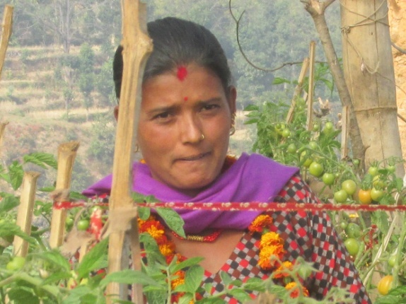

Date of Birth: 2040-8-27 B.S

1983-12-13 AD

Age: 37 years

Gender: Female

Birth place: Sindhupalchok

Father’s name: Kedarnath Aryal

Mother’s name: Chitra kumari Aryal

Husband’s name: Tika Prasad Gautam

A story of Self confidence

Born on Dec 13 1983 on Sindhupalchok district Sano Sirubari VDC as 3rd children of Mr. Kedarnath Aryal and Mrs.Chitra Kumari Aryal among 7 children’s, without any formal education Bina’s childhood was not good at all. At early age of 8 due to family issues she was child labored in a house in Chawuni-Kathmandu, at a very small age she was forced to word from morning 4-o-clock until 10-o clock at night. Cleaning the five stored house, washing dishes, sending the children’s of the house owner who were almost same as her age to the school and bringing them back, watching the children’s of her age going to school she also dreamed of going to the school but her dreams never turned into reality, she was not doing households works only but she was also working in the chicken husbandry collecting the eggs of the chicken, while sometimes she used to sleep while collecting the eggs and used to wake up when scolded by the owner. During Saturday she used to wash the clothes of her house owner and his family. Taking a flash back of her past she never thought of getting the life she is living now for her everything seems like a dream.

While meetings her friends and family after seven years she felt like she got a new life and her struggling days were over but her happiness didn’t last long when she found out that she was taken home to get married. She said she was shocked when she heard that she was getting married and wanted to run away from there but there was nothing she could do.

On the date 2056 at the early age of 15 she got married to Mr.Tika Prasad Gautam of Kubinde-6, Sindhupalchok and got separated form father in law and mother in law just after 3 months of marriage both of them were just children’s when they have to face difficulties for fulfillment of their basic needs like food and shelter, they didn’t used to have any knowledge and plans about the future. After some time Bina’s husband left home in search of work for 3 years while Bina have to face many difficulties during this period sometimes she couldn’t even eat full appetite also but she never told anyone about the difficult situation she was facing not even to her father and mother due to superstitions in the society, After some time her husband learned construction work and at 2064 BS they took loan and build their house which relieved Bina somehow. Bina’s first child was born at age of 18 but when she reached age of 27 she gave birth to 4 more children’s which added more responsibilities and more struggle for them. Slowly she started to get involved in the other activities in the village she wanted to join the women groups established in her village, wanted to do new works but she couldn’t do it because she was not involved in any women groups due to her financial status since the groups were established long time ago and she didn’t used to have that much money. Slowly she started to explain the importance of group and make the other women’s in the village aware about the benefits working in the group rather than working isolated as a result she was successful to establish a women group named Shrijansil Women Saving Group on 2071-4-1 BS with 15 members with the help of BBP Pariwar.

While the regular events were being carried out by the groups the group members decided to send me to the leader farmer training being conducted on Sindhuli with the support of the BBP Pariwar (support of world Neighbors) and SIDS Nepal Sindhuli on 2071-9-4 BS till 2071-9-11 which lifted up my self confidence and after the training I started to relay the things that she have learnt to the group members and started to practice in my behavior as well. Then I established a plastic pond to collect the wasted water and started the cultivation of vegetables and tomatoes in the wasted land. Although i was not able to take good care due to the big earthquake last year (2072BS) I sold the garlic and onion of 5000 rupees, tomatoes of 7000 rupees, which increased my self confidence and motivated me to do the farming with business motive. This year my target is to generate 40000 rupees form vegetable farming. I have cultivated vegetables like tomatoes, garlic, onion, green leaves, cucumber, pumpkin, potatoes etc. I have received rupees 17000 from tomatoes until now other vegetable farming is also good. I am not using any pesticides or chemical feces in the vegetables rather I am using the vermicompost, organic pesticides produced at home. I am able to fulfill the needs of my children’s as I am able to generate income from farming. I have a will to do more work and to be a leader farmer and I wanted to bring change in the life of other women members of my group.

I am very thankful to the organization for sending me in the leader farmer training which helped me to develop my self confidence.

Sabitri Giri:

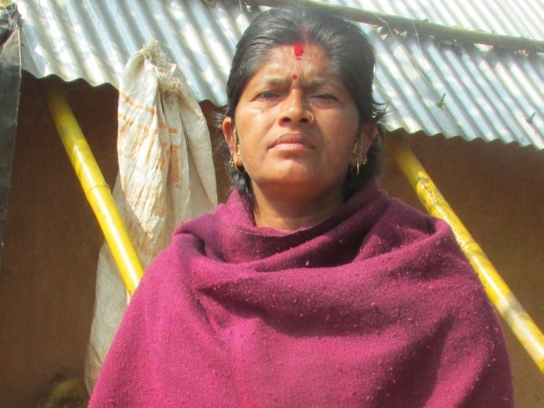

Date of Birth: Jestha 2026 BS

1969 May AD

Age: 52 years

Birthplace: Mahadevsthan, Kavre

Father’s Name: Sovit Bharati

Mother’s Name: Kali Bharati

Husband’s Name: Ram Bahadur Giri

New Life

There is a saying that “life is a struggle” where we have to face unexpected events and difficulties. This is a story of Sabitri Giri of Kavre Mahadevsthan born on 2026 on the month of Jestha; she was the first child among 4 children’s of Mr.Sovit Bharati and Mrs. Kali Bharati. At that time due to social tradition she was deprived from education, she was busy taking care of her small brothers and sisters and doing household works rather than going to school due to which she can’t even write her name as well.

Time was passing by; at the small age of 13 years she got married to Mr. Ram Bahadur Giri of age 26 living in Mandandeupur-9, Kavre. She has to take responsibilities at the small age while other child’s used to go to school, play and her husband also mostly used to stay outside due to Army’s job, she was taking all the responsibilities of the house. At the age of 15 she gave birth to a child but she couldn’t save him more than 10 days. She stated that if there was facility of clinic and the regular checking she wouldn’t have lost her child. She gave birth to 2 children when she reached 20 but she stated that she never got a chance to go for the checkup, neither she knew about the reproductive health nor her family member made her understand regarding the checkup during pregnancy.

I was interested to be involved in a group watching her neighbors being involved in a group. Finally i got involved in Bacchaladevi Women Saving Group on Falgun 2073, on the same date i got involved in a group; BBP Pariwar organized a health awareness program especially focused on the cancer of the cervix. And the social mobilizer’s of the BBP Pariwar had informed all of the members of the group to attend the camp for the checkup for cancer of the cervix which was going to be held on Samaj Sewa Samuha Kuntabesi on the date 2073 Chaitra 19. But i didn’t pay any attention because i felt like i was healthy, as i never felt any symptoms. And felt like why should I do the checkup? But considering the words of the social mobilizer’s i thought of checking up once just to be clear regarding my health status.

On the date of the camp i.e. 2073-12-19 i went to Samaj Sewa Samuha for the checkup and was found positive in the VIA Test. At first I didn’t understood what was the meaning of VIA Positive, Sisters conducting the camp informed me to do the checkup in Banepa city once. Following the instruction of the sisters I went to Banepa for the checkup and from Banepa the doctor recommended me to Bhaktapur cancer hospital and I went there. After i checked up at Bhaktapur cancer hospital I got the report on the 7th day and found out that i was on second stage of cervix cancer, everyone of my family members were shocked when they knew about my report because we used to hear the rumors that cancer patients will not survive and felt like I was going to die soon, at that time all I could think of was about my family members and started to cry. The doctors started to consult me and told me not to worry and informed me that I was in the initial stage and informed that I would be cured and they have to start the treatment. According to the advice of the doctors I had to undergo 5 chemotherapies. I got the first chemo on date 2073-2-4, after the chemotherapy i felt very weak I was not able to walk also during that time I felt like I was about to die watching my condition my husband was angry and started to blame sisters of BBP Pariwar thinking that her wife was fine but they made me sick and I will die but the reality was that I was about to get a new life because of them. But slowly with the help and support and care of BBP Pariwar I was able to develop self confidence. My hair started to fall when I was undergoing the second and third chemo, observing the other patients on the hospital I thought that I came for the checkup early, after my 4th chemotherapy the doctor told that there was no need of the 5th chemotherapy. My health condition was getting better and after 3-4 months of the treatment at Kathmandu finally I got cured and came home I am fine now, I can do some households works, I can walk for the monthly meetings of the group.

I am very thankful to BBP Pariwar for providing me a new life; maybe I couldn’t be alive even after getting the treatment if I was not suggested for the checkup on time by the staffs of the BBP Pariwar, if the treatment was started late may I couldn’t be saved by money. Now I am even convincing the other women’s in my society as well to do the checkup and I am very thankful once again to the Social Mobilizer’s and the BBP Pariwar for providing me a new life.

Laxmi Bishowkarma:

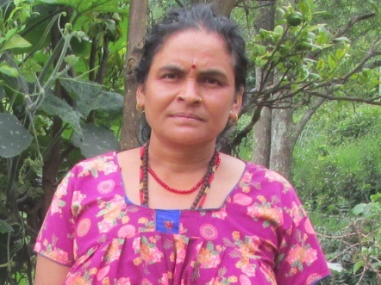

Date of Birth: 2035-4-18 BS

1978-8-2 AD

Age: 43 years

Birthplace: Pipal Dada, Sindhupalchok

Father’s Name: Tika Bahadur Bishowkarma

Mother’s Name: Naradevi Bishowkarma

Husband’s Name: Makar Bahadur Bishowkarma

Dream Came True

On the date 2035-4-18 BS Laxmi B.K was born as a second child of Mr. Tika Bahadur Bishowkarma and Mrs. Naradevi Bishowkarma at Pipal Dada, Sindhupalchok district. All the family members were very happy on her birth but the happiness didn’t last long, as her mother died when she was small. Laxmi didn’t got a chance of going to school, rather than going to school she used to be busy taking care of her small brothers and sisters, household works, cow and goats herdsman. At the small age of 11 she used to go for labor. She used to get 10 rupees per day.

Days were passing by, as per the rituals of the society she got married at the early age of 13 on date 2048 to 18 years old Mr. Makar Bahadur Bishowkarma living at Chautara-6, Kubinde. She was totally unknown about what marriage was and she didn’t knew that she have to do a lot of work as well, even for bringing the water it used to take around 3- 4 hours, sometimes she used to fall down and all her time and her effort used to be wasted. She used to go to jungle for the grass for livestock but couldn’t carry more and less was not enough. She used to get scolded and sometimes beaten by her husband and her mother in law. She couldn’t eat full appetite even at time when she got hungry. All her past seemed like a dream to her now. Until the age of 24 she gave birth to 3 children’s but she never went to hospital or clinic for the checkup despite, she didn’t even knew that she have to go for the checkup. She didn’t get to eat full appetite after the delivery and even couldn’t get proper rest as well. She used to do all the household works just after 2-4 days of delivery and even used to go to work in the fields after 10 -12 days of delivery. While talking about her past she had tears in her eyes but her confidence level never decreased and she always had a will of learning new works.

I didn’t knew, what is a Group? What are the benefits of the being a part of group for us? I used to wonder while other woman’s used to tell they have a group meeting today. Slowly women’s of my society also started talking about the groups the social mobilizer’s representing an organizations also started to explain about the importance of the group but I didn’t used to have a confidence in me that even the lower class (dalit) women’s like us could be a part of the group and work with other women’s. Slowly we established a group named Srijansil Women Saving Group on the date 2071-4-1 BS until then we didn’t know that we have to elect the chairperson, vice chairperson, secretary and treasurer, i was hearing this for the first time. After discussion the group members elected me as a chairperson but I couldn’t sleep the whole night thinking that I may not be able to fulfill the responsibilities handed over to me by the members. I was afraid and nervous because I couldn’t even say my name in front of the mass, I was afraid about how to speak, what to say about group in front of the social mobilizer’s of an organization but slowly I started to fulfill my responsibilities.

We made a group and started to do savings also but I was afraid that the social mobilizer’s may take our savings and run away. Time was passing by, and then 2 members of our group were given a chance to join the farmer’s educational tour to Sindhuli. The group decided to send me and selected one other member and we went for the visit, there we met other new women members of other women groups and listening to their experience I started to have a trust on the organization and social mobilizer’s. The objective of the visit was to observe and gain knowledge about the activities of the groups conducted by other women like us. Observing the activities like stall improvement, vermicompost production, vegetable farming, cultivation of fodder grasses, collection of the wasted water and its utilization I realized that if we have a will to do the things there is always a way and I thought implementing the things I have learned from the tour and also thought of encouraging the other group members also. On the next day we returned from the visit I made a plastic pond for the collection of the wasted water and went Chautara to buy vegetables seeds. I started the vegetable farming by taking the advice of the social mobilizer’s of the BBP Pariwar and in that year I earned around 8000 rupees by selling the vegetables that year. The next year I was able to generate an income of 10000-12000 by selling vegetables like, chilly, tomatoes, string beans (Bodi), onion and green leaves, I am planning to extend the vegetable farming. Especially the people in my caste do not cultivate vegetables my relatives also started cultivating the vegetables watching me.

Nowadays I don’t have to depend on my husband for saving in the group rather I am giving the money that I have earned from vegetables to my husband and even I have planted some fodder grasses and started the livestock husbandry also, now I can fulfill my desires, there was a time when I couldn’t even eat the food I liked, buy the things I liked, my sisters used to buy the things for me but now they are happy that I able to fulfill some of my desires. I developed a confidence even to speak in front of the mass, I am able to convince the members of my group, BBP Pariwar is also supporting us well, and slowly I have a thought of registering the group in agriculture and livestock and I am also discussing with the group members as well.

I heartily thank BBP Pariwar and the social mobilizer’s of BBP Pariwar for providing the opportunity for the women’s of the lower casts like us and the women of the backwarded communities and the support provided for making us self dependent.